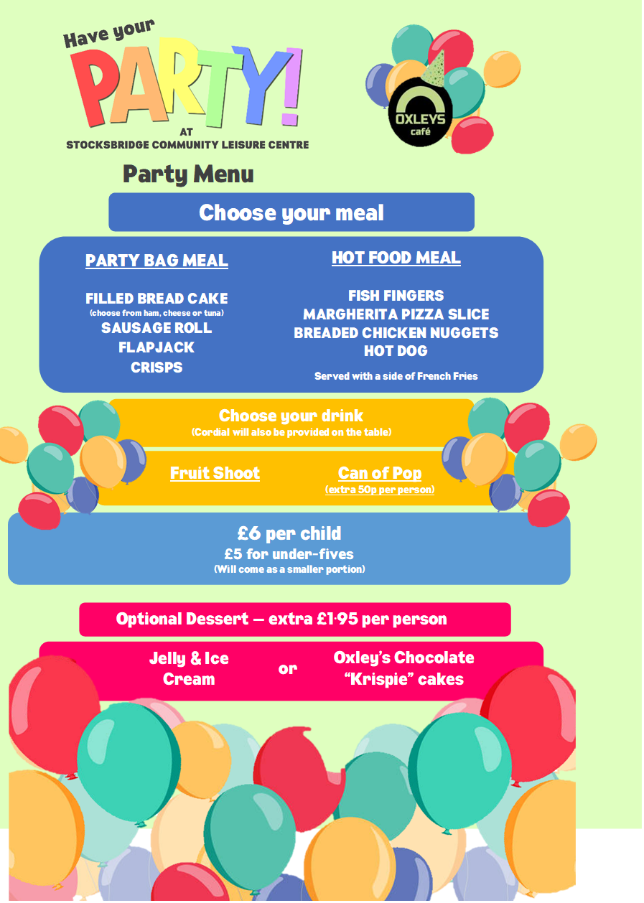

Contact Name: | Click or tap here to enter text.
Contact Number: | Click or tap here to enter text.
Contact Email address: | Click or tap here to enter text.
Date of Party: | Click or tap here to enter text.
Time of Party | Click or tap here to enter text.
Food Serving Time: | Click or tap here to enter text.
Number of Children: | Click or tap here to enter text.

Party Bag Meal | Quantity | Additional Comments
Ham | Click or tap here to enter text. | Click or tap here to enter text.
Cheese | Click or tap here to enter text. | Click or tap here to enter text.
Tuna | Click or tap here to enter text. | Click or tap here to enter text.

Hot Food Options | Quantity | Additional Comments
Fish Fingers | Click or tap here to enter text. | Click or tap here to enter text.
Margherita Pizza Slice | Click or tap here to enter text. | Click or tap here to enter text.
Breaded Chicken Nuggets | Click or tap here to enter text. | Click or tap here to enter text.
Hot Dog | Click or tap here to enter text. | Click or tap here to enter text.

Drink Options | Quantity | Additional Comments
Fruit Shoot | Click or tap here to enter text. | Click or tap here to enter text.
Can of Pop (50p per person extra) | Click or tap here to enter text. | Click or tap here to enter text.
Plant based alternatives available for all food options
Click here and detail any special dietary requirements and a member of our team will contact you to discuss:-
The cost per child for a dessert is £1.95 and is not included in the £6. If you would like to add this one, please call or email.
Options | Quantity | Additional Comments
Jelly and Ice Cream | Click or tap here to enter text. | Click or tap here to enter text.
Oxley’s Chocolate Krispie Cakes | Click or tap here to enter text. | Click or tap here to enter text.

For Internal use only Age of Child:
Date order received from customer:
Full Payment Received from Customer: | Date: | Total Amount:

