Stocksbridge Community Leisure Centre

Volunteering Opportunities
At SCLC

Come And Join Our Wonderful Volunteer Team!

Volunteering At SCLC

There is no doubt, Stocksbridge Community Leisure Centre would not be where we are today without the overwhelming and continued support from the local community. Our volunteer army provide us with many hundreds of hours cleaning, repairing, fixing, painting and gardening to help keep the Centre operational.

Volunteering can be a very rewarding way of helping a worthy cause. Not only are you helping us, you can also meet new people, make new friends, socialise and develop new skills – or pass yours onto a younger generation.

Volunteers give up their time freely to help out in whatever way they can. Anyone over the age of 16 is welcome to join our team of unpaid ambassadors. You don’t have to have a skill, just a commitment to what we are trying to achieve. A multi-purpose community run Leisure Centre on our doorstep. If you have a skill – even better. If you have skills in administration, reception, supervision (general or sport related), accounting, roofing, plumbing, electrics, decorating, gardening, or anything else you think we might find useful please think about volunteering.

You can volunteer a few hours or many hours – it’s up to you. It doesn’t matter how old you are or if you have a disability. You can volunteer your time at weekends, during weekdays or in the evening.

If you want to be involved in making Stocksbridge Community Leisure Centre a success, then call Julie Martin, Assistant Centre Manager – Operations on 0114 2883792, or email admin@stocksbridgeclc.co.uk for further details. Alternatively, you can complete the Volunteer Application Form at the back of the booklet and return to the Leisure Centre Reception.

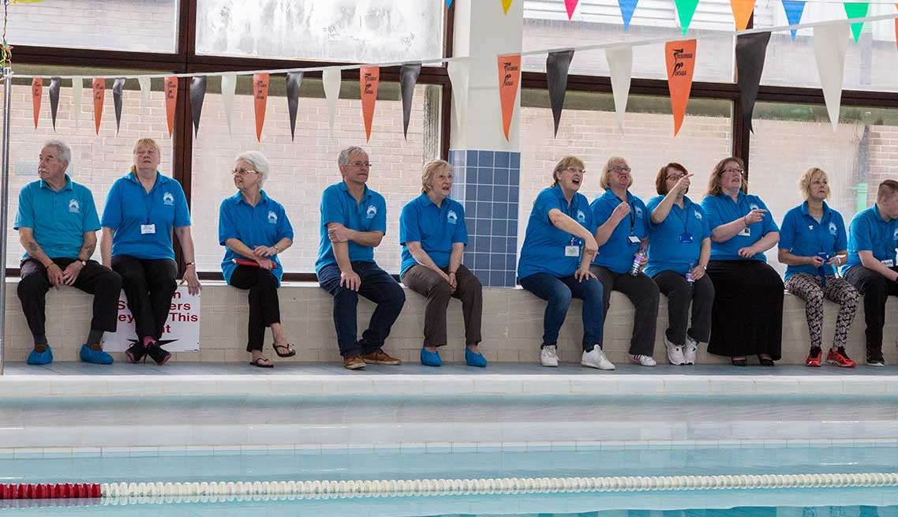
Comment’s From Our Volunteer Team
Please see below comments from our fabulous team of volunteers at SCLC and what volunteering at the Leisure Centre means to them:
It’s brilliant volunteering here at SCLC. I love to help out and be part of their Fundraising Events. I also completed my Bronze Duke Of Edinburgh Award (Voluntary Section) within the office at SCLC. (Emily – Age 16)

Volunteering at the Leisure Centre for me is working with lots of fabulous people, developing new skills and roles. (Sarah – Age 33)

One of the things that I missed when I first retired, was meeting a variety of people. The Leisure Centre has lots of friendly people working there, so it made a lot of difference to me socially. It is also such a vital and important health facility for the community. (Jane – Age 68)
Volunteering at SCLC gives me great satisfaction that I have given something worthwhile that helps my community. (Michael – Age 64)
(Michale – Age 64

After 3 years, I still think it was the best decision I ever made. All the staff are great - like a family, and its lovely meeting all the customers, a lot I know from years back, or their kids/grandkids. It’s a real community feel and I’m proud to be part of it. (Karen – 58)
I love volunteering at SCLC with likeminded people, who have a team goal to make our Leisure Centre the best for everyone. (Tracy – Age 50)
I became a volunteer after I retired. I needed something to keep my mind and body active. I enjoy meeting people and helping wherever
I can.
(Jenny – Age 71)

I have been volunteering at SCLC for the last 6 years, helping out with reception and admin. It's great to work with such a lovely, friendly, supportive bunch of staff and volunteers. I enjoy meeting new people and also seeing people I haven't seen for years. Come and join us, it's a very worthwhile cause. (Tessa – Age 64)

Volunteering for the Leisure Centre is enjoyable and fun. It is truly gratifying to work for this wonderful place and everyone who uses the facility, also knowing that I have had a hand in keeping it in the community. (Angie – Age 67)

((
Volunteering for the last few years has been very rewarding. It makes you feel part of the community and worthwhile, fulfilling a role which is needed as part of the smooth running of the Leisure Centre. It is a fabulous way of meeting so many new friends and acquaintances and doing something which is so worthwhile.
(Viv – Age 77)

Volunteering at the Leisure Centre is enjoyable, interesting and making a contribution to the community. It’s also an opportunity to get out of the house and meet people. (Keith – Age 64)

I am an 81 year old pensioner who volunteers on Reception at SCLC. Volunteering gives me a reason to get up in a morning. The Staff are friendly and Management are appreciative for our time. If you have a couple of hours to spare each week, give it a go, you may enjoy it and you will be helping our Community.
(Jack – Age 81)

Volunteer Application Form
Personal Details
Name
Address
Postcode
Telephone Numbers |  |  |  | Mobile:  Landline:
Email Address
Emergency Contact Information
Employment Status
Qualifications
Details Of Any Medical Conditions/Allergies Which We Need To Be Aware Of.
Areas Of Volunteer Interest & Details Of Other Skills Offered
Areas Of Interest  (please tick) |  | Reception/Admin  Café  Cleaning  Pool Responding |  |  |  | Pool Responding  Painting/Maintenance/Gardening  Fundraising Events:  Sport Related Supervision
Other Skills
Availability
Days | Monday |  | Tuesday |  | Wednesday | Thursday | Friday | Saturday | Sunday
Times  (please tick) | Morning  Afternoon  Evening |  | Morning  Afternoon  Evening |  | Morning  Afternoon  Evening | Morning  Afternoon  Evening | Morning  Aft  Evening | Morning  Afternoon  Evening | Morning  Afternoon  Evening
Emergency Cover | Would you be happy for us to contact you at short notice? Yes: No:

Data Protection

All information supplied is stored in accordance with the General Data Protection act and will only be used for record purposes whilst volunteering here at Stocksbridge Community Leisure Centre, as well as supplying you with information that we feel will be of benefit to you.
We will not pass your details onto any third party, but we may make you aware of offers from our corporate sponsors from time to time.
Please tick here if you are happy for us to contact you with information or offers, not directly related to on the volunteering opportunities applied for on this form
(Please Return Your Completed Form To SCLC Reception)

Stocksbridge Community Leisure Centre
A Company Limited by Guarantee with Charitable Status. Company No. 08413664 Charity No. 1153527
Stocksbridge Community Leisure Centre, Moorland Drive, Stocksbridge, S36 1EG
Tel: (0114) 288 3792

