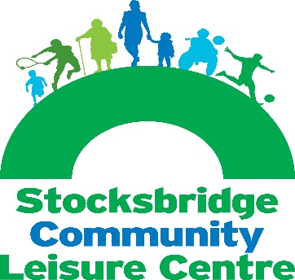
Stocksbridge Community Leisure Centre
Moorland Drive, Stocksbridge
Sheffield S36 1EG

T: 0114 288 3792
E: admin@stocksbridgeclc.co.uk
W: www.stocksbridgeclc.co.uk

4SLC For Stocksbridge Leisure Centre Trust
Membership Form (Individuals)
Company Limited By Guarantee Number 08413664
Registered Charity 1153527

Objects of the Charity
- To provide or assist in the provision of facilities for the benefit of the community in Sheffield, Barnsley and Kirklees (the “area of benefit”) for recreation, amateur sports and games or other leisure time occupation in the interests of social welfare, such facilities being provided to the public at large with the object of improving their conditions of life, save that special facilities may be provided for persons who by reason of their youth, age, infirmity or disability, poverty or social or economic circumstances may have need of special facilities and services. In furthering this object the trustees will operate Stocksbridge Leisure Centre for the public benefit.
- To promote and preserve good physical and mental health in the area of benefit.
- To further establish such other charitable purposes beneficial to the community in the area of benefit consistent with the objects above as the trustees in their absolute discretion determine.

Agreement for Membership and Guarantee
I hereby apply to become a full member of this company limited by guarantee and agree to be bound by its memorandum and articles of association and any rules made under these. I confirm that I support the company’s aims and work.

Should the company be wound up, I promise to pay the sum of up to £10 towards its debts, if asked to do so, and I understand that this liability will continue for one year after I cease to be a member of the company. I agree that the Company may give out information about me to other members.

Name

Address

Postcode

Telephone

4SLC For Stocksbridge Leisure Centre Trust
(A Company Limited by Guarantee with Charitable Status – Company Number 08413664, Charity Number 1153527)

Stocksbridge Community Leisure Centre
Moorland Drive, Stocksbridge
Sheffield S36 1EG

T: 0114 288 3792
E: admin@stocksbridgeclc.co.uk
W: www.stocksbridgeclc.co.uk

Fax

Email

Signature

Data Protection
All information supplied is stored in accordance with the General Data Protection Act and will only be used for the purpose of managing your Trust membership, as well as supplying you with information that we feel will be of benefit to you.
We will not pass your details onto any third party, but may make you aware of offers from our corporate sponsors from time to time. Please tick here if you are happy for us to contact you with information or offers, not directly related to the Trust membership applied for on this form ⃝
For further details of our Privacy Policy, please refer to our web site – www.stocksbridgeclc.co.uk

__________________________________________________________________________________________________

Office use only: Date Membership accepted

Office use only: Date Membership ceased

Please return this form to Julie Jennings, Stocksbridge Community Leisure Centre, Moorland Drive, Stocksbridge, Sheffield, S36 1EG, admin@stocksbridgeclc.co.uk.

Membership is open to anyone who completes this form. Applications for membership will be considered by the company’s directors. Membership is terminated if the member gives written notice of resignation, ceases to exist, is removed from membership by resolution of the directors or ceases to comply with the conditions of membership. Membership is not transferable.

4SLC For Stocksbridge Leisure Centre Trust
(A Company Limited by Guarantee with Charitable Status – Company Number 08413664, Charity Number 1153527)

